**Homework 5:** Dijkstra’s algorithm

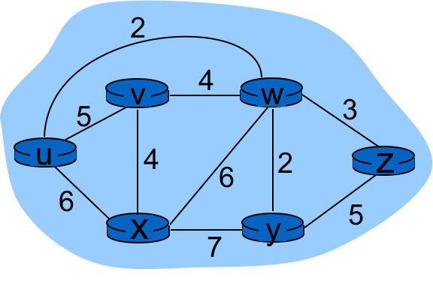

Using Dijkstra’s algorithm, find the least cost path from source ***u***to all other destination. Fill out the table below using the same format as done in class.

|  |  |  |  |  |  |  |
| --- | --- | --- | --- | --- | --- | --- |
| **N’** | **D(u), p(u)** | **D(v), p(v)** | **D(w), p(w)** | **D(x),p(x)** | **D(y), p(y)** | **D(z), p(z)** |
| u |  | 5u | 2u | 6u | Inf | inf |
| uw |  | 5u |  | 6u | 4w | 5w |
| uwy |  | 5u |  | 6u |  | 5w |
| uwyz |  | 5u |  | 6u |  |  |
| uwyzv |  |  |  | 6u |  |  |
| uwyzvx |  |  |  |  |  |  |

Based on the above, fill out the entries in the Forwarding Table of Router ***u***. Assume the interfaces in u are numbered as follows: link u-w is interface 0, link u-v is interface 1 and link u-x is interface 2.

|  |  |
| --- | --- |
| **Forwarding Table** | |
| **Destination** | **Outgoing Interface** |
| v | 1 |
| w | 0 |
| x | 2 |
| y | 0 |
| z | 0 |